Install the Software Token Application
Note: If you already have the application installed
Start the application
Click Options – Import Token
Skip to the Import Your New Token section below.

- Download the RSA Token Installer package using the link below.
Copy the RSASecurIDToken502x64.msi file
from here \\tdorg\bounty\public\RSA_SoftToken_Install\PC\Token 5.0.2
to your Desktop so it is easy to find.
Wait for the copy to complete.
- Double-Click RSASecurIDToken502x64.msi from your desktop.
Click Run at the Security Warning.
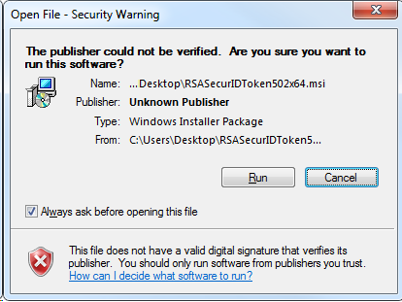

- Welcome
Click Next
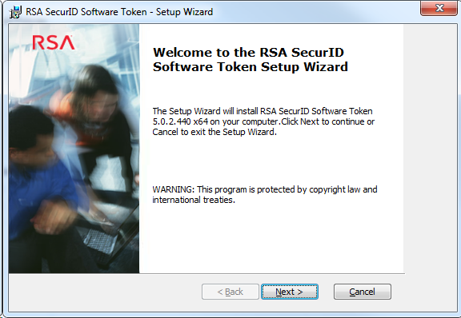
- License Agreement
Click I accept the terms in the license agreement
Click Next
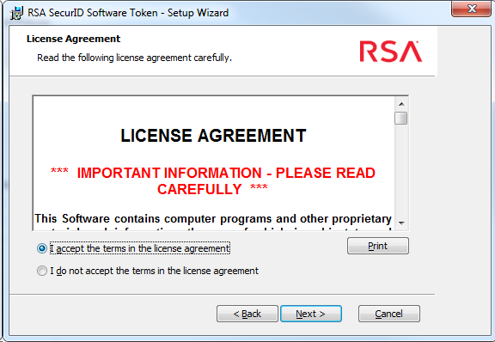

- Setup Type
Make sure Typical is selected
Click Next
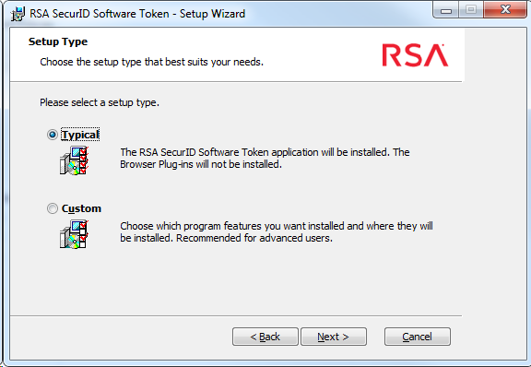

- Ready To Install
Click Install
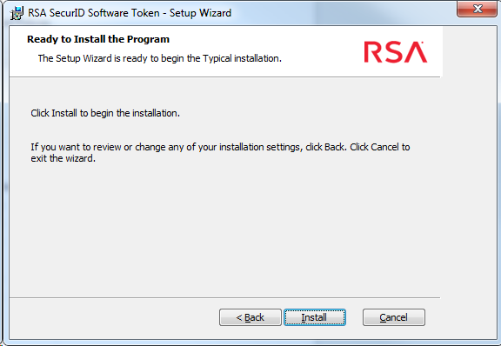

- InstallShield Wizard Completed
Click Launch RSA SecurID Software Token
Click Finish
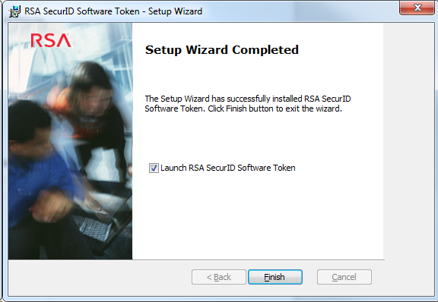

Import Your New Token

- Import Token
Click Import from Web
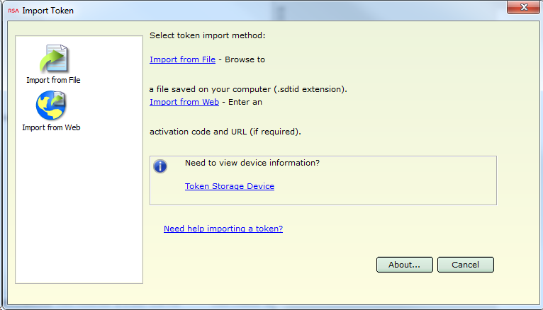

- Import From Web
Enter URL: Copy and paste this URL https://ccradius.td.teradata.com:7004/ctkip/services/CtkipService
into the Enter URL: field. (Do not click the URL directly from this document).
Enter Activation Code: Use the activation code provided via email.
Note: Your activation code is unique to your account and can only be
used one time. If you reinstall the application or install on a new PC at a
later date then please request a new code.
Click Ok
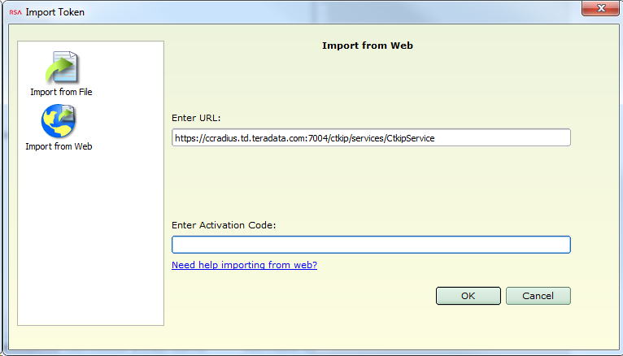
- Select Device
If you see the Select Device window
Click OK
Select a drive letter (usually C:\ ) when prompted
Click OK
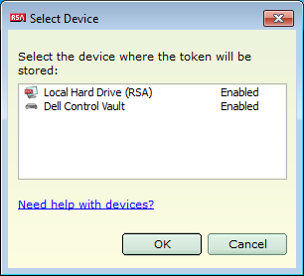
RSA SecurID Token
Your token was successfully imported when you see this message.
Click OK
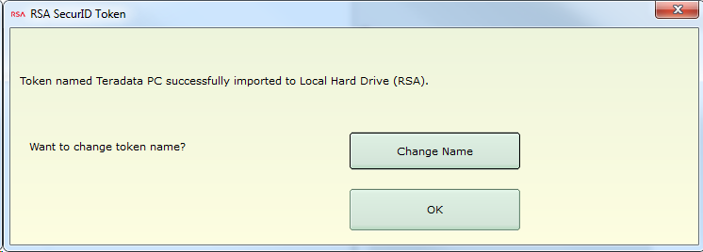

Log In and Test the Token

- Wait for the token code to change.
- Log in to either Axeda ServiceConnect (http://serviceconnect.teradata.com) or the VPN Gateway (https://sslgateway.teradata.com)
Your password is the pin + tokencode.
For example:
If you have set your pin to cat1dog and the software token is displaying 4615 2378
Then use cat1dog46152378 as the password.
It is quick and easy to
Type your pin
Click Copy on the Software Token
Paste (Ctrl+V) into the Password field.
There is no space in the tokencode if you choose to type it in rather than copy and paste.
- If you log in to both ServiceConnect and the VPN Gateway
Wait for the token code to change before logging in to the second application.

Appendix A: Managing Multiple Tokens
You may have multiple software tokens if a customer has also given you a software token. In that case this section may be helpful to you.
- The token codes that are generated for each of the tokens you have imported will not be the same.
You select the token whose token codes you wish to see as shown below.
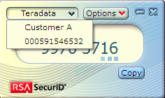
In this example we have one token named Teradata and another named Customer A that have been imported.
Teradata is the active token and we have clicked on the name to show the list of available tokens.
Clicking on Customer A in the list will make it the active token and show token codes generated for the Customer A token.
- You can use the Change Name button during the import process to give the token a name that makes it easy to identify.
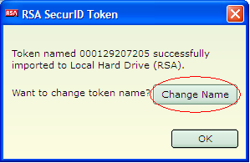
- You can also change the name of a token that has already been imported anytime you wish.
Select the token that you wish to rename and make it active.
Click Options – Manage Token – Change Token Name
Type the name you wish to use
Click Ok
